27.77: 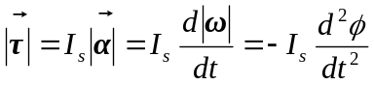
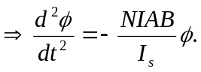

This describes simple harmonic motion with 